**PROJECT DESIGN PHASE - 1**

SOLUTION ARCHITECTURE

|  |  |
| --- | --- |
| Date | 19 September 2022 |
| Team ID | **PNT2022TMID04228** |
| Project Name | **Real-Time River Water Quality Monitoring and Control System** |
| Maximum Marks | 4 Marks |

**SOLUTION ARCHITECTURE:**

Solution architecture is a complex process – with many sub-processes – that bridges the gap between business problems and technology solutions. Its goals are to:

* Find the best tech solution to solve existing business problems.
* Describe the structure, characteristics, behaviour, and other aspects of the software to project stakeholders.
* Define features, development phases, and solution requirements.
* Provide specifications according to which the solution is defined, managed, and delivered.

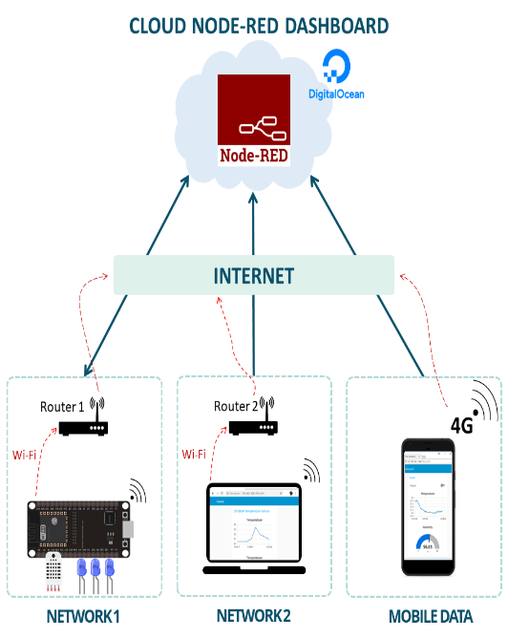



[This Photo](https://www.freepngimg.com/png/68515-development-web-iot-ibm-of-internet-watson) by Unknown Author is licensed under [CC BY-NC](https://creativecommons.org/licenses/by-nc/3.0/)

user interface





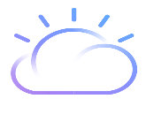

[This Photo](https://www.freepngimg.com/png/67865-bluemix-ibm-computing-watson-interface-open-cloud) by Unknown Author is licensed under [CC BY-NC](https://creativecommons.org/licenses/by-nc/3.0/)

WIFI/INTERNET

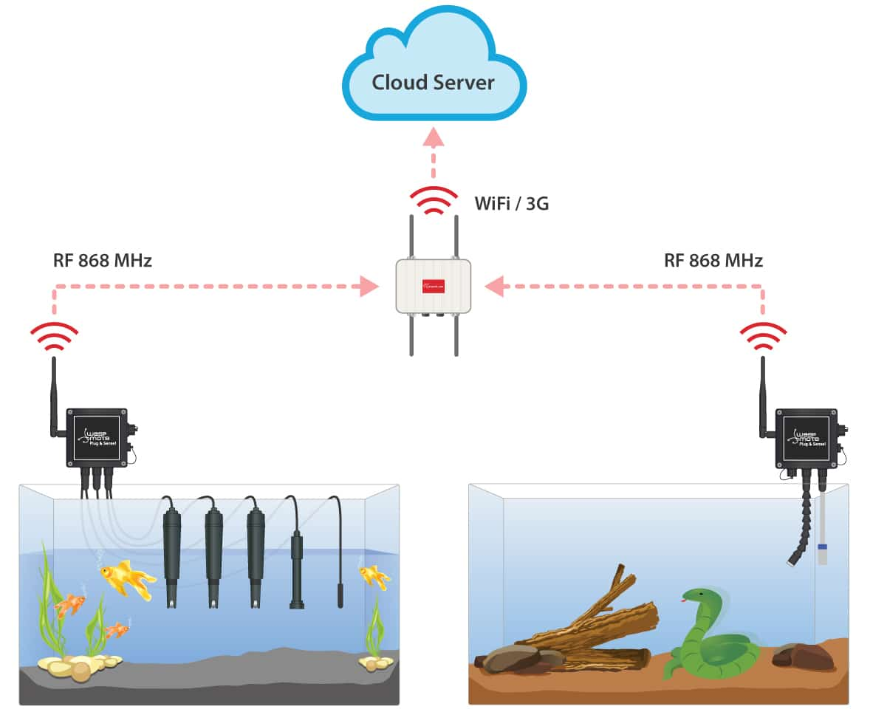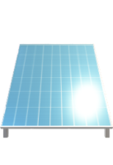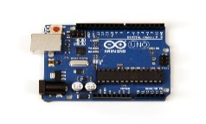

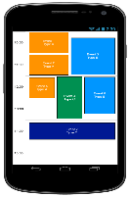

[This Photo](http://stackoverflow.com/questions/14306446/best-way-to-implement-day-view-schedule-android-ui) by Unknown Author is licensed under [CC BY-SA](https://creativecommons.org/licenses/by-sa/3.0/)

python random data

sensing water quality

REMOTE ACCESS

FLASH SMS

SOLAR POWERED

IOT WATSONPLATFORM

IBM cloud

MCU